SCHOOL NAME: Liverpool Street Elementary
Address: 50 Liverpool St
Parent School Support Committee
Minutes
Date: Sept 23, 2021 Time: 6:30pm
Location: Microsoft TEAMS
PSSC Members Present:  Ronnie Stewart, Chair  Colin Curry, Vice Chair  Keri O’Leary, Teacher Rep.  Tara Swift  Bronwyn Mulherin-Murphy  Asha Noel-Hart  Erica Fanjoy  Erin Wilson  Sabina Thapa  PSSC Members Regrets:  Siddaiah Madadevaswamy | School/DEC Representation Present:  Kelly Parks, Principal  School/DEC Representation Regrets:  Jennifer Kelly-Milner, Vice Principal
Call to Order: by Ronnie Stewart

Approval of the Agenda:

- Approval of the Minute: Motioned by Ronnie Stewart, seconded by Colin Curry

- Welcome to our new members
- Erica Fanjoy
- Erin Wilson
- Sabina Thapa
- Committee members:
Ronnie Stewart- Chair
Colin Curry- Vice Chair
Tara Swift- Parent
Michelle Wuest- Parent: Michelle has decided that she is unable to take part this year due to other commitments.
Asha Noel-Hart- Parent
Bronwyn Mulherin-Murphy- Parent
Siddaiah Mahadevaswamy- Parent
Keri O’Leary- Teacher Rep (new this year on committee)
Jennifer Kelly-Milner- Vice Principal
Kelly Parks- Principal
- PSSC Committee to introduce themselves.
- Healthy and safe schools document updates
- Recess time is separated by grade levels at this time. We have grade 2 & 3 outside together and grade 4 & 5 outside together to reduce the number of students on the playground at one time. We have also split the playground down the middle and are doing our very best to follow regulations for keeping students in grade level groupings while outside (A & B). Students will switch sides each week.
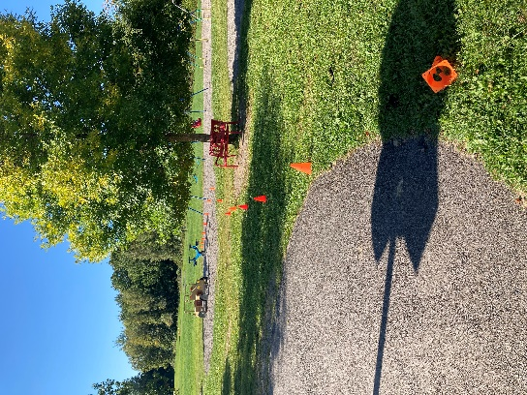

- No reading buddies or Math buddies for now.
- No assemblies at all in person. All must be virtual. ** Members asked if it was possible to do outdoor assemblies weather permitting and Mme. Parks said that was definitely something the school administration is looking into **
- Only outdoor field trips are allowed and to stay in grade level groupings.
- Students will continue to wear their masks inside the building including when doing physical activity in the gym and in their classrooms. Masks can be removed when students are eating, drinking or when outside. Phys Ed classes have taken place outside everyday since the announcement was made.
- Teachers are moving to teach English to Immersion and PIF/English to grade 4, not the students.
- Resource teachers last year had to do smaller group work due to covid restrictions. At the last principal meeting many questions were asked as to if Resource could still do small groups within a grade level, but this question, along with many others have yet to be answered and District Office is still working on finding answers for us.

- Playground equipment- new car, titter totter, swings and safety swing as well as a concrete picnic table. I have sent an email to Adam at city of Fredericton to ask about playground structure. There was also an abundance of garbage on the playground when we returned for this school year since extra garbage bins were placed over the playground. We have since asked to have these bins removed and the garbage was cleaned up.
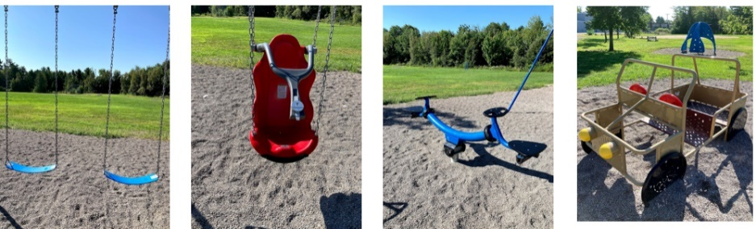

- Principal Report
1. 13 classes
- 7 FI Classes
- 6 English classes
- 2 of which are split classes
2. Total student Enrollment =268
3. Traffic flow- much better having myself outside at 7:45am at drop off to meet students. The students are going straight to their classrooms. There are about 30-35 students that arrive before 8. We have 2 teachers on duty in the halls from 7:45-8:00. School begins at 8:15am.
4. Apple picking trips – school wide- hay ride, apples and corn maze
5. PL for Grade 2 English Prime teacher- new building blocks of reading.
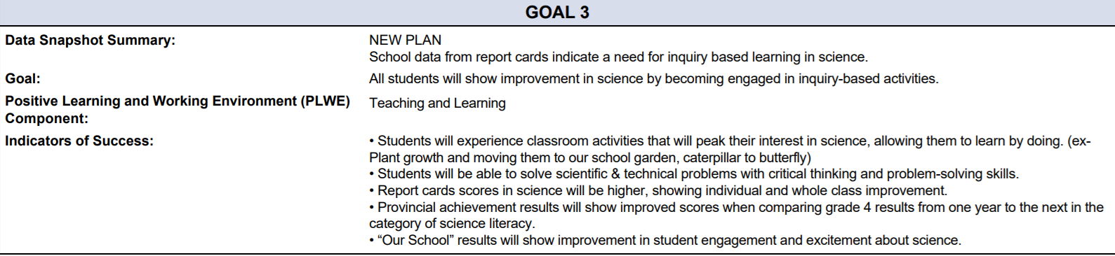
6. School Plan – new goal science while our math and literacy goals remain.

7. Computer room- with fewer students in our school this year we have an extra classroom that we have made into a computer lab. We purchased long power bars and have desks set up in a U-shape. The computers remain on the desk and students only open the laptop, power it on and they are good to go. We would eventually like to turn this room into a combined computer room/maker space to go along with our science goal.
- Next meeting: October 21, 2021 at 6:15pm- Is 6:15pm still a good time for members?
Tentative dates for meetings:
Oct 21
Nov 18
Jan 20
Feb 17
March 31
May 12

Business from Previous Meeting: none

Business Arising from the Minutes:
- Members commented on the amount of refuse around the dumpster and donation bins that are in the school parking lot. Mme. Parks said that the school has placed a lock on our dumpster to alleviate our bin getting full over each weekend; however, it seems to be collecting outside it now. Is there a way we can have these relocated or will it continue to happen with the dumpster. Mme. Parks will look into having this cleaned up / relocated as it is not safe for the students walking by.
Sept 25- Mme Parks spoke with community Living, who was at the school to collect donations in the community bin. They volunteered to take the items to the dump for the school. A donation was to Community Living was made by Mme Parks to thank them for their kind offer.
(New Business / agenda):

- Busses – are they all sorted out now? Transportation has mentioned that more drivers are being trained. This will help in putting bus runs back on route. Our district is helping schools to get the late bus list in another means other than twitter so schools can assist parents in getting the information when posting late / non-running busses so they can inform their families better on who is affected.
- Artist in Residency – can our school apply for this? We have done so in the past and will continue to as the students really enjoy it and are engaged. Unsure at this time is artists can come into the building or not with the tightening of restrictions. Would be better engagement for students if they were present and not done over web cam.
- Reconciliation Day – what is the school preparing? We have our special events committee that is planning activities for that day. Story books have been purchased by the school with lessons attached for the teachers to use. Posters have arrived and our District Subject Coordinator has sent out numerous lessons for teachers to use that day.
- Drama Musical – on hold at the moment until further clarification
- Extra-Curricular Activities – cannot happen at the moment where students must be bubbled.

Correspondence:

Closing Comments: Wonderful to meet so many new members this year!

Date of Next Meeting: October 21, 2021

Adjournment: 8:00pm

Motioned by Ronnie Stewart, seconded by Tara Swift

